This module is all about working using DevOps principles and techniques. You will learn how software development is more like craftwork than factory work and that working in silos leads to mistakes and bottlenecks. You will see how DevOps is driven by behaviors such as collaboration and embracing change. You will be introduced to concepts such as ephemeral infrastructure that emphasizes building quickly and then discarding when that build is no longer needed. You will learn a more effective style of work in which you make changes to container images and redeploy a new container to take its place instead of patching and maintaining it. You will learn about new processes such Continuous Integration and Continuous Delivery that enable frequent deployments and working as a team to create high-quality code. You will learn how to move faster, use automation, and spend more time building features and less time debugging during integrations.

### **Learning Objectives**

* Describe the negative effects of working in silos.
* Recognize why software engineering projects should not be treated like civil engineering projects.
* Describe the behaviors emphasized in DevOps.
* Describe the benefits of using Infrastructure as Code in a DevOps environment.
* Describe how Continuous Delivery enables release to production at any time.
* Describe how Continuous Integration creates more stable code.

—----------------------------------------------------------------------------------------------------------------------------

## Video 1: Taylorism and Working in Silos

**—---------------------------------------------------------**

This lecture discusses the core concepts of DevOps and the drawbacks of applying Taylorism (an industrial management style) to software development. Here’s a summary of the key points:

1. **DevOps Culture and Collaboration**: DevOps emphasizes collaboration and teamwork. It's inspired by Agile principles, valuing “individuals and interactions over processes and tools.” This is critical because a strong DevOps culture relies on teams working closely to achieve shared goals.
2. **Automation**: Automation is central to DevOps. By automating routine tasks, teams can focus on delivering frequent, smaller releases, enabling faster feedback loops and reducing risk. Automation isn't the sole focus of DevOps, but it’s essential for rapid response and efficiency.
3. **Small, Frequent Releases**: DevOps advocates for small, incremental releases. This minimizes risk, makes it easier to detect and fix problems, and fosters continuous learning. Quick, actionable feedback enables teams to improve faster and with less disruption.
4. **Taylorism and Software Development**: Taylorism, named after Frederick Taylor, is a management method from the industrial revolution that optimized assembly-line production by dividing labor into specialized roles (silos) under command-and-control management. This approach can work well in manufacturing but doesn't suit software development, where each project is unique, and flexibility is key.
5. **Software as Craftwork**: Software development is more like craftwork than factory work. Developers create bespoke applications, tailored to specific needs, rather than replicating the same product repeatedly. Treating software like factory work leads to inefficiency because it involves numerous handoffs, creating bottlenecks, loss of context, and higher risk of errors.
6. **Trusting Skilled Workers**: Quoting Steve Jobs, the lecture emphasizes trusting talented team members to take ownership and drive innovation. Managers should provide direction but avoid micromanagement, allowing teams to leverage their skills and creativity.

### **Real-Life Examples**

* **Automation in DevOps**: In a web development company, automated testing scripts allow developers to check code continuously without manual input, saving hours of work and quickly identifying issues. This fosters a faster development cycle and reduces time-to-market.
* **Abandoning Silos**: A company might eliminate siloed roles by forming cross-functional teams that include developers, testers, and operations working on the same project. Instead of a linear workflow, everyone collaborates, solving issues in real-time, leading to fewer delays and a stronger sense of ownership.
* **Frequent Releases**: Apps like Instagram or Spotify release new features and updates frequently, gathering feedback and making adjustments based on user responses. By pushing small updates, they minimize the risk of major failures and keep users engaged with fresh features.

In summary, DevOps fosters a collaborative culture, frequent updates, and automation, while Taylorism’s rigid, siloed structure hinders innovation. Treating software development as craftwork, with trust in skilled team members, aligns with modern, efficient development processes.

—---------------------------------------------------------------------------------------------------------

## Video 2:Software Engineering vs. Civil Engineering

—--------------------------------------------------------------------------------------------------------

This lecture highlights the unique nature of software engineering and why the traditional project management model, often used in civil engineering, doesn’t work well for software development. Here’s a summary of the key insights:

1. **Difference Between Software and Civil Engineering**: In civil engineering, once a project (e.g., building construction) is designed and executed, the architect hands it off to the construction team. After the construction phase, the building is handed over to a maintenance team, with few modifications expected over time. This static, linear process, where each phase operates independently, is suitable for civil engineering but problematic for software engineering.
2. **Software Engineering is Dynamic**: Software continuously evolves; operating systems are patched, new features are added, and security updates are implemented. This ongoing change in underlying software and infrastructure creates challenges if managed with a “build and handoff” approach. The project model, which assumes a project has a set completion, doesn’t accommodate the organic, ever-evolving nature of software.
3. **Drawbacks of the Project Management Model**: Project-based management in software development creates issues with ownership and continuity. Teams develop software, then hand it off to operations, which often leads to a disconnect, as the original developers have moved on, leaving little in-depth understanding or commitment to the software’s ongoing quality.
4. **Product Development Mindset for Software**: Rather than treating software as a short-term project, viewing it as a long-term product with a dedicated team is more effective. This product-centric approach keeps teams involved in the software’s lifecycle, enhancing accountability and familiarity, and empowering developers to improve the code over time.
5. **DevOps Approach and End-to-End Ownership**: In DevOps, stable, long-term teams with full ownership of the software foster deeper understanding and a commitment to quality. This model reduces issues with handoffs, where context or quality is often lost, and creates a stronger culture of accountability and innovation.

### **Real-Life Examples**

* **Long-Term Product Teams**: In companies like Amazon and Google, teams that build products often remain with them, handling updates and new features. This ensures they retain a strong understanding of the system, leading to consistent improvements over time without disruptions or knowledge loss.
* **Constant Software Updates**: Operating systems (e.g., Windows, iOS) frequently push updates to patch vulnerabilities or improve features. If these systems followed a traditional project-based model, the teams responsible for these updates would be constantly rotating, leading to slower patches, reduced quality, and increased security risks.
* **DevOps in E-commerce**: An online retail platform might treat its application as a product rather than a project. The same team handles everything from development to updates and user feedback. This consistent involvement allows the team to rapidly address any issues that arise due to updates or changes in the tech stack, enhancing the user experience and maintaining security.

In summary, the project model's fixed nature doesn’t align with the fluid demands of software engineering. By adopting a product-oriented approach with dedicated, stable teams, DevOps provides the environment for creating, maintaining, and continuously improving high-quality software.

—----------------------------------------------------------------------------------------------------------------------------

## Video 3:Required DevOps Behaviors

—---------------------------------------------------------------------------------

This video explores the fundamental differences between traditional Ops and DevOps, addressing how the two groups view each other and what behavioral changes are required to implement DevOps successfully. Here's a breakdown of the main points:

1. **Opposition Between Traditional Ops and DevOps**:
   * In traditional enterprises, "new" is often seen as risky, expensive, and time-consuming. New projects are treated as one-time efforts with a fixed scope, timeline, and budget.
   * DevOps, in contrast, promotes breaking down large projects into smaller, manageable changes, which can be delivered more quickly and with less risk. This iterative approach enables continuous improvements and reduces the dangers associated with large, complex projects.
2. **Clashing Cultures of Dev and Ops**:
   * Traditional Ops emphasizes manual processes, relying on change review boards and change windows to manage risks. These manual tasks are prone to human error and slow down progress.
   * DevOps automates deployments across all environments, reducing the need for human intervention and increasing speed. It also prioritizes **ephemeral infrastructure** (temporary resources created for each new deployment) instead of the "build once, maintain forever" approach of traditional Ops.
3. **Manual vs. Automated Approaches**:
   * Traditional Ops handles risk by making changes only during designated windows, while DevOps manages risk through **progressive activation**—deploying changes at any time and adjusting them as necessary.
   * Traditional Ops builds manual, often undocumented infrastructure, leading to "snowflake servers" that are difficult to replicate. DevOps counters this by using **Infrastructure as Code** to make builds repeatable, reliable, and scalable.
4. **Dev and Ops Misunderstandings**:
   * **Ops View of Devs**: Operations often see developers as throwing incomplete or poorly tested code over the wall, leaving Ops to deal with the fallout. Developers are perceived as not accounting for real-world operational constraints.
   * **Devs View of Ops**: Developers see Ops as rigid and slow, creating bottlenecks by enforcing change windows and manual processes, often lacking an understanding of the code due to distance from its development.
5. **Breaking Down Silos**:
   * Traditional Ops and Devs operate in silos with different goals. Development focuses on innovation and fast feature deployment, while Ops prioritizes stability and reliability, often leading to conflicts and a "wall of confusion."
   * DevOps seeks to **remove these silos**, encouraging shared ownership and high collaboration between teams, which helps create a common goal of delivering value to the customer.
6. **Required DevOps Behaviors**:
   * **Shared Ownership**: Everyone should work toward a common objective, with no division of responsibilities that could lead to blame-shifting when things go wrong.
   * **Embracing Change**: DevOps promotes frequent, small changes to minimize risk. Large changes are harder to control and more likely to introduce problems.
   * **Ephemeral Infrastructure**: Servers and infrastructure should be deployed using automated, repeatable processes, not built manually. This ensures consistency and speeds up deployment.
   * **Automated Self-Service**: Instead of relying on ticket queues or manual provisioning, DevOps encourages self-service tools to empower developers to work independently and efficiently.
   * **Data-Driven Feedback**: DevOps emphasizes fast feedback loops using data to monitor performance and react quickly to issues in production.

### **Real-Life Examples**

* **Automation in Cloud Infrastructure**: Many modern companies use Infrastructure as Code (e.g., Terraform, Ansible) to automate the creation and management of cloud infrastructure. This automation enables teams to scale their infrastructure easily and deploy new features faster, in contrast to the manual, slow processes of traditional Ops.
* **Continuous Deployment**: Companies like Netflix and Amazon release updates frequently using DevOps principles. Instead of waiting for long release cycles, they deploy small, incremental changes, reducing risks and improving user experience.

### **Conclusion**

The video emphasizes that DevOps is fundamentally different from traditional Ops in that it seeks to break down silos, automate manual processes, and embrace constant change through small, iterative updates. By shifting from the rigid project management model to a product-focused approach, DevOps encourages collaboration, innovation, and continuous improvement, benefiting both developers and operations.

—----------------------------------------------------------------------------------------------------------------------------

## Video 4: Infrastructure as Code

—----------------------------------------------------------------

This lecture explains key concepts in DevOps and modern infrastructure management—Infrastructure as Code (IaC), ephemeral infrastructure, and immutable delivery—alongside tools that enable them, like Docker, Ansible, Puppet, and Kubernetes. Here’s a focused summary with practical examples:

### **Key Points and Real-World Applications**

1. **Infrastructure as Code (IaC)**:
   * *Definition*: IaC refers to describing infrastructure setup in code (text files) rather than manual configurations, allowing developers to create, update, and manage infrastructure through executable scripts.
   * *Advantages*: IaC provides consistency and reproducibility by storing all infrastructure changes in version control, reducing errors common with manual configurations and allowing easy rollback.
   * *Tools*: Ansible, Puppet, Chef, Terraform, and Kubernetes support IaC.
   * *Example*: Imagine a business launching a web app. Instead of configuring each server individually, developers use IaC to set up servers, networks, and databases quickly. If one server fails, IaC can recreate it without manual intervention, ensuring reliability and minimizing downtime.
2. **Ephemeral Infrastructure**:
   * *Definition*: Infrastructure is treated as temporary (ephemeral), created only when needed and discarded after use.
   * *Advantages*: Ephemeral infrastructure avoids server drift—gradual inconsistencies that can lead to failures—by allowing identical, transient infrastructure to be set up repeatedly as needed.
   * *Example*: A company testing software might deploy a test environment with IaC and discard it once testing is complete. If they need it later, they can quickly recreate it, eliminating the cost and complexity of maintaining unused environments.
3. **Immutable Delivery and Containers**:
   * *Definition*: Immutable delivery uses containerization to package applications along with their dependencies, ensuring consistency across environments. Changes are made to the container image (template) rather than modifying running containers.
   * *Advantages*: This approach supports seamless rollbacks, reduces environmental differences, and prevents configuration drift within containers.
   * *Example*: A team working with a microservice architecture could use Docker to deploy each service in its own container. If an update fails, they quickly roll back by stopping the faulty container and launching the previous version.

### **Practical Benefits**

This approach enhances scalability and reduces downtime. For instance, e-commerce platforms may deploy containers for increased site traffic during a sale, and reduce infrastructure afterward. Similarly, if an update introduces a bug, teams can revert to a stable container version without affecting other services, ensuring a smooth user experience.

—----------------------------------------------------------------------------------------------------------------------------

## Video 5: Continuous Integration

—---------------------------------------------------------------------

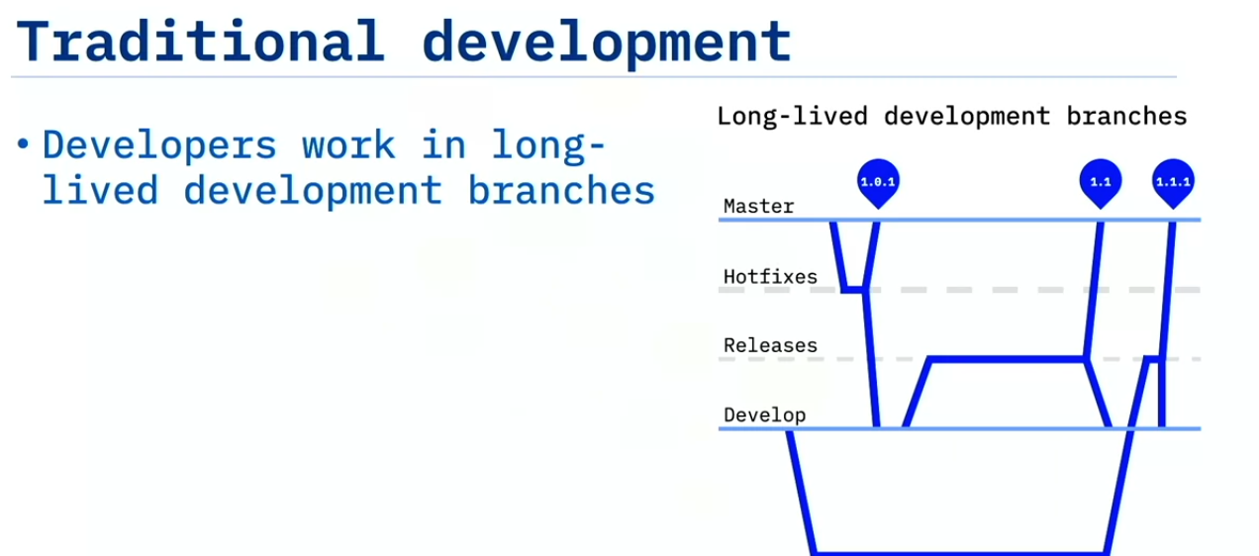

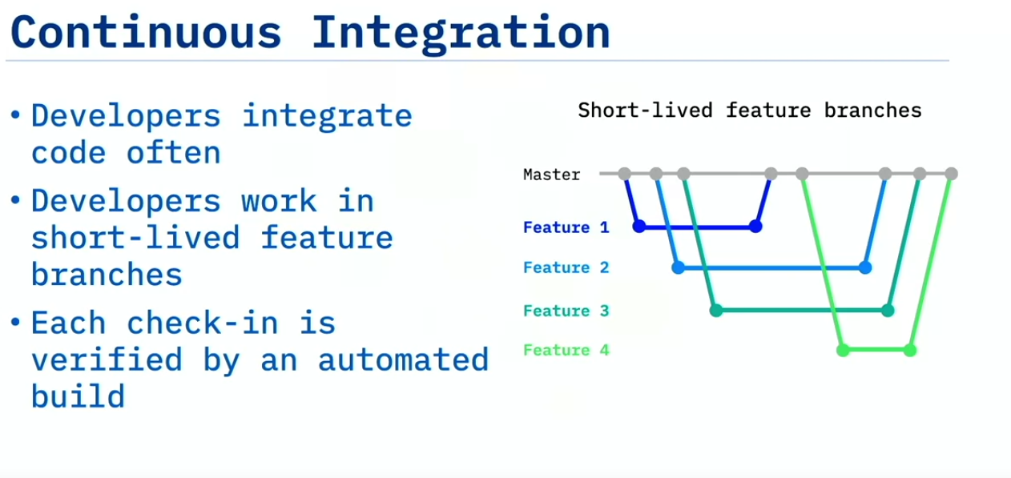

This lecture highlights the principles and benefits of Continuous Integration (CI) and Continuous Delivery (CD), which together form the foundation of modern DevOps practices. Here’s a summary of the main points and practical examples to illustrate their real-life impact.

### **Key Points and Real-World Applications**

1. **Continuous Integration (CI)**:
   * *Definition*: CI is a development practice where code changes are frequently integrated into a shared repository (ideally daily), ensuring that each integration passes a series of automated tests.
   * *Benefits*: CI allows for faster issue detection, fewer integration conflicts, and improved code quality due to frequent testing and feedback.
   * *Example*: Suppose a team is developing an e-commerce platform. With CI, every feature (e.g., adding a new payment option) is integrated into the main codebase only after passing automated tests. This approach ensures that any issues are caught early, preventing costly rollbacks or debugging of broken features after deployment.
2. **Continuous Delivery (CD)**:
   * *Definition*: CD involves continuously preparing code for deployment by delivering changes to a production-like environment. It doesn't require the changes to go live in production but ensures they are ready to deploy.
   * *Benefits*: CD enables safe, rapid deployment to production by preparing code in environments similar to production, reducing deployment risks and making releases smoother.
   * *Example*: For a mobile app with weekly feature updates, CD allows developers to deploy new code to a staging environment that mimics the production environment. This way, developers catch potential issues in a controlled setting, reducing the risk of failures in the live app and enabling a smoother rollout of new features.
3. **Working in Small Batches**:
   * *Definition*: Developers commit small, frequent code changes rather than large updates over an extended period, reducing the chance of conflicts and merge issues.
   * *Benefits*: Small batch changes decrease the risk of merge conflicts, make issues easier to pinpoint, and improve productivity by streamlining testing and integration.
   * *Example*: If a team of developers builds a website, each might focus on a small feature like a search bar, a user profile, or a payment button. By committing these smaller updates frequently, they avoid merging large sets of code that can break other components, allowing quicker feedback and smoother collaboration.
4. **Automation and CI/CD Tools**:
   * *Definition*: Tools like Jenkins, GitHub Actions, and Travis CI monitor code changes, automatically trigger builds, and run tests, making it easy to maintain CI/CD pipelines.
   * *Benefits*: Automation reduces the manual effort required for testing and deployment, speeds up the feedback loop, and enhances reliability.
   * *Example*: An organization using GitHub Actions automates the testing of every code pull request. When developers submit changes, GitHub Actions automatically builds and tests the code, providing feedback within minutes. This immediate response allows developers to address issues immediately, maintaining code quality and stability.

### **Practical Benefits**

CI/CD practices increase code quality and enable faster, safer deployments. For example, when adding new features to a banking app, CI/CD helps ensure these features work seamlessly with existing ones. Testing and deploying in small batches also allow the team to catch and address bugs early, ensuring a reliable user experience and rapid feature delivery. By incorporating CI/CD into development, companies can achieve consistent, deployable code and move faster in a competitive environment.

—----------------------------------------------------------------------------------------------------------------------------

## Video 6: Continuous Delivery

—--------------------------------------------------------------

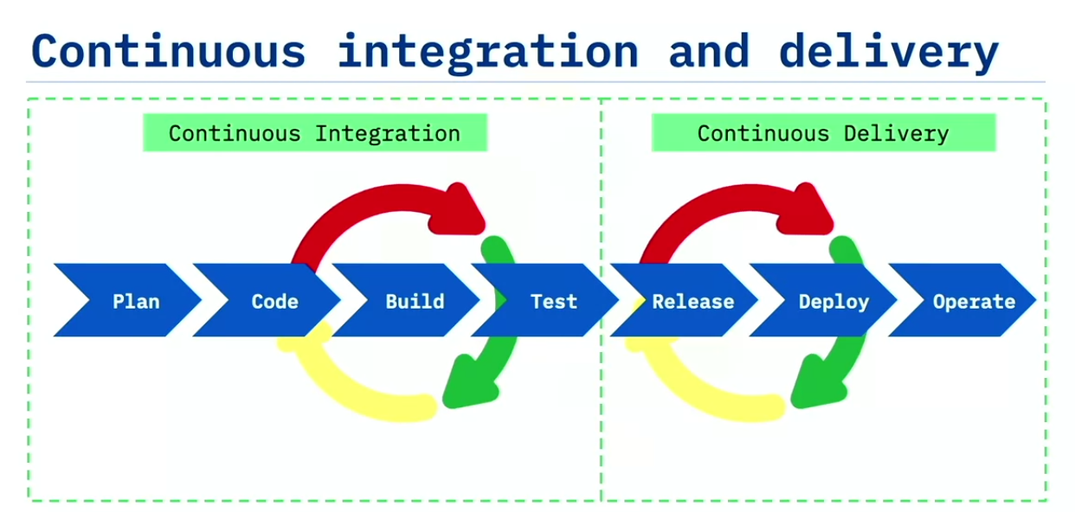

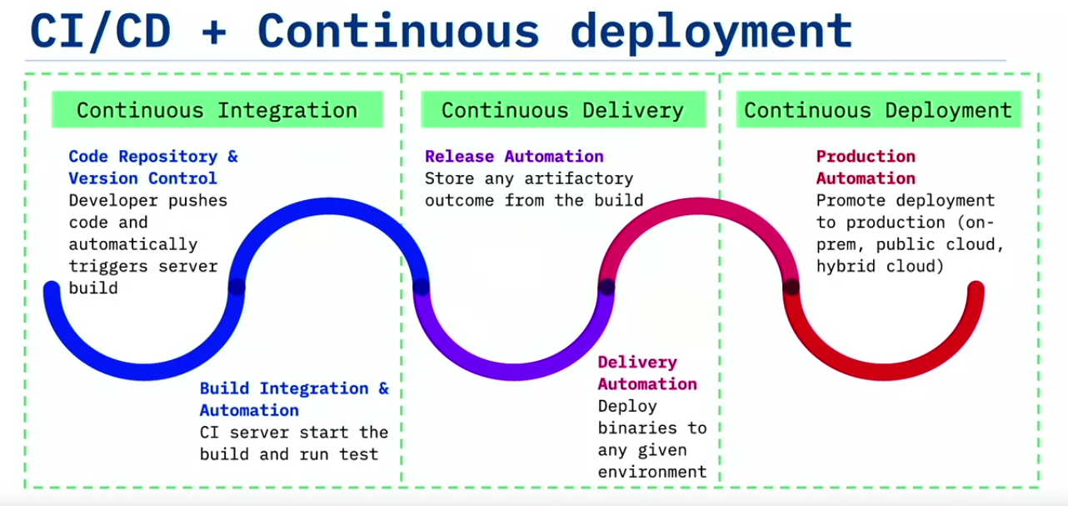

This lecture on Continuous Integration (CI) and Continuous Delivery (CD) provides a clear overview of CI/CD principles, pipeline components, and real-life benefits for software development, emphasizing how DevOps can manage risks through automation and frequent deployments.

### **Key Concepts:**

1. **Continuous Delivery (CD)**: A development approach where software is built to be deployable at any time. Martin Fowler defines it as ensuring the master branch is always deployable. CD requires **Continuous Integration** (CI)—building and testing each change to avoid potential breakages.
2. **CI/CD Pipeline**: A set of automated steps that move code through various testing and quality gates until it is ready for deployment. This pipeline includes:
   * A **code repository** (e.g., GitHub) to host the code.
   * A **build server** to compile code into application files.
   * An **integration server** that runs tests and scans for vulnerabilities.
   * An **artifact repository** to store successfully built files.
   * **Deployment automation tools** to streamline setup and manage different environments, from development to production-like.
3. **Five Principles of Continuous Delivery**:
   * **Built-in Quality**: Each code change undergoes rigorous testing and quality checks.
   * **Small Batches**: By committing small changes frequently, there is less risk and easier debugging.
   * **Automation of Repetitive Tasks**: Using computers for routine work (e.g., building and testing) frees up people for problem-solving.
   * **Continuous Improvement**: Regular measurement and action on feedback to enhance the process.
   * **Shared Responsibility**: All team members collaborate to resolve issues, especially when builds break.
4. **Continuous Deployment**: This is an extension of CD where all approved changes are automatically deployed to production. It ensures reliability by simulating production repeatedly in non-production environments, so any issue is detected before the final deployment.
5. **DevOps and Risk Management**: Rather than minimizing changes, DevOps reduces risks by encouraging frequent, small updates. Automation ensures consistent deployments across environments, and strategies like **feature flags** (enabling/disabling features without redeployment) and **canary testing** (gradual release of a feature) allow controlled, zero-downtime deployments.

### **Real-Life Examples:**

* **E-commerce Website Updates**: An e-commerce site that continuously integrates new features and bug fixes can use a CI/CD pipeline to ensure the main branch is deployable. This minimizes downtime and ensures new features are consistently ready for customers.
* **Feature Flags in Social Media Platforms**: Platforms like Facebook use feature flags to roll out updates in stages. A feature may only be visible to a small percentage of users initially. This allows developers to monitor performance and feedback before expanding the release to all users.

### **Benefits:**

* **Efficiency**: Automated testing and frequent deployments allow faster, reliable development and more time for innovation.
* **Quality Assurance**: Frequent code checks and peer reviews through pull requests keep code quality high.
* **Risk Reduction**: Small, frequent updates reduce the chance of large-scale issues, while controlled deployment methods like canary testing enable real-time monitoring and rollback if issues arise.

In summary, a CI/CD pipeline fosters reliable, efficient, and safe development practices by focusing on automation, small updates, and collaborative responsibility, making it ideal for modern, dynamic software projects.

—----------------------------------------------------------------------------------------------------------------------------

# **Summary and Highlights**

Congratulations! You have completed this lesson. At this point in the course, you know:

* Taylorism was designed for factory work and software development is bespoke, that is, more like craftwork, and that working in silos leads to mistakes and bottlenecks.
* Team ownership and stable teams make software development more like product development rather than project management.
* Developers want innovation, while Operations want stability.
* Required DevOps behaviors include shared ownership, collaboration, embracing change, and data-driven responses.
* Infrastructure as Code is describing infrastructure in a textual executable format.
* Ephemeral infrastructure can be used and then discarded because servers are built on demand, via automation, using Infrastructure as Code techniques.
* Continuous Integration is building, testing, and integrating every developer change into the master branch after tests have passed.
* The benefits of Continuous Integration include faster reaction time, moving faster, and reducing the risk in integrating code.
* Continuous Delivery ensures that code can be rapidly and safely deployed to production by delivering every change to a production-like environment.
* The five principles of Continuous Delivery have to do with quality, working in small batches, automation, continuous improvement, and shared responsibility.

## 

## 

## 